**EXPERIMENT 11**

SQL > create Bank ( BankID number(3) primary key , bankname varchar(100), headoffice

varchar (100), branch varchar (100), branchcode number (5) );

insert into Bank values (1, 'State Bank of India', 'Mumbai', 'Alappuzha', 101);

insert into Bank values (2, 'HDFC Bank', 'Trivandrum', 'Kottayam', 102);

insert into Bank values (3, 'ICICI Bank', 'Mumbai', 'Ernakulam', 103);

select * from Bank;

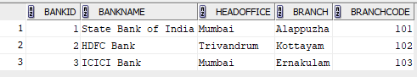

User 1 > grant select on Bank to c22csa36;



After GRANT by User 1

User 2 > select * from c22csa35.Bank;

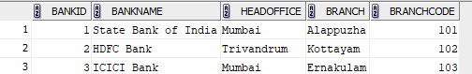

User 1 > revoke select on Bank from c22csa36;



After REVOKE from User 1

User 2 > select * from c22csa35.bank;



After GRANT by User 2

User 1 > select * from c22csa36.bank;

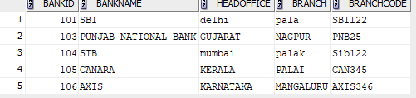

User 1 > update c22csa36.bank set bankname='UBI' where bankid=104;

select * from c22csa36.bank;

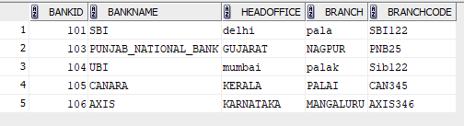

After REVOKE by User 2

User 1 > select * from c22csa26.bank;



commit;